**Assignment-1**

1. **Hello World Program: Write a Java program that prints "Hello World!!" to the console.**

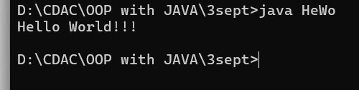

**2. Compile with Verbose Option**: **Compile your Java file using the -verbose option with javac. Check the output.**

Ans – verbose command used in javac to find the runtime of the current java file to show what compiler is doing at runtime.

-verbose command is used to check whether all the classes are loaded correctly or not, its used for debugging purpose.

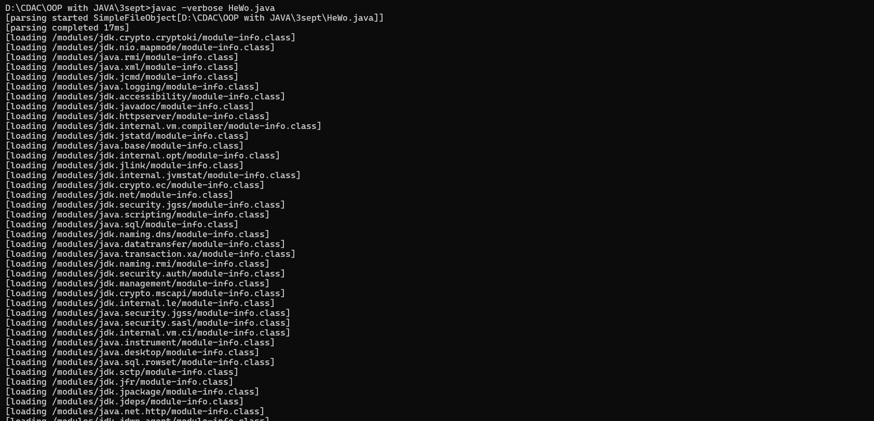

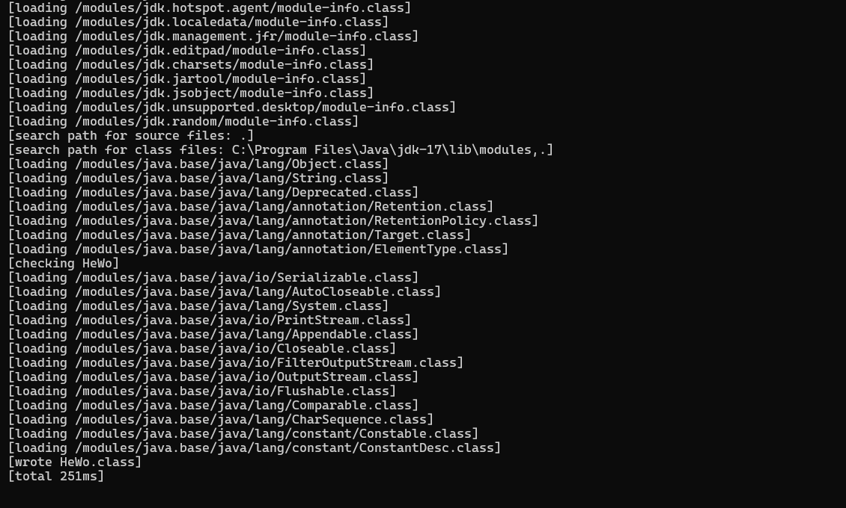

**3.Inspect Bytecode**: Use the javap tool to examine the bytecode of the compiled .class file. Observe the output.

